Blockchain Assignment 12
Write solidity program to find gross salary for provided basic salary
- If Basic Salary <= 10000 : HRA = 20%, DA = 80%



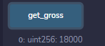

- If Basic Salary <= 20000 : HRA = 25%, DA = 90%



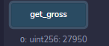

- If Basic Salary > 20000 : HRA = 30%, DA = 95%


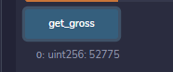

Code:
//SPDX-License-Identifier:MIT

pragma solidity ^0.8.0;

contract find_gross_salary{

uint256 private hra;
uint256 private da;
uint256 private grossSalary;

function gross_salary(uint256 _gross) public returns (uint256)
{
if (_gross <= 10000)
{
hra = _gross * 20 / 100;
da = _gross * 80 / 100;
grossSalary = _gross + hra + da;
return grossSalary;
}
else if (_gross <= 20000)
{
hra = _gross * 25 / 100;
da = _gross * 90 / 100;
grossSalary = _gross + hra + da;
return grossSalary ;
}
else
{
hra = _gross * 30 / 100;
da = _gross * 95 / 100;
grossSalary = _gross + hra + da;
return grossSalary ;
}
}

function get_gross() public view returns (uint256)
{
return grossSalary;
}
}

